Report of Assignment 1. Ostapovich Oleg.

[Simple graph](https://app.diagrams.net/?tags=%7B%7D&title=PUMA.drawio#Uhttps%3A%2F%2Fdrive.google.com%2Fuc%3Fid%3D1-3QZR-CjXO9UimsThUHUT1G2gCnOtKXX%26export%3Ddownload) of my [model](https://www.researchgate.net/publication/311953769_INVERSE_KINEMATICS_ANALYSIS_OF_A_PUMA_ROBOT_BY_USING_MSC_ADAMS):

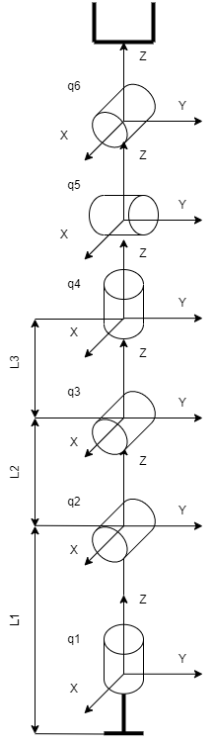

Forward kinematics: